
VICTORIA JUNIOR COLLEGE

JC2 PRELIMINARY EXAMINATIONS 2024

H2 GEOGRAPHY 9173/02
Paper 2

INSERT 3 hours

READ THESE INSTRUCTIONS

The Insert contains all the Resources referred to in the questions.

This document consists of 8 printed pages.
Resource 1 for Question 1

Four sites of investigation chosen by the students based on a flood hazard map by the city government

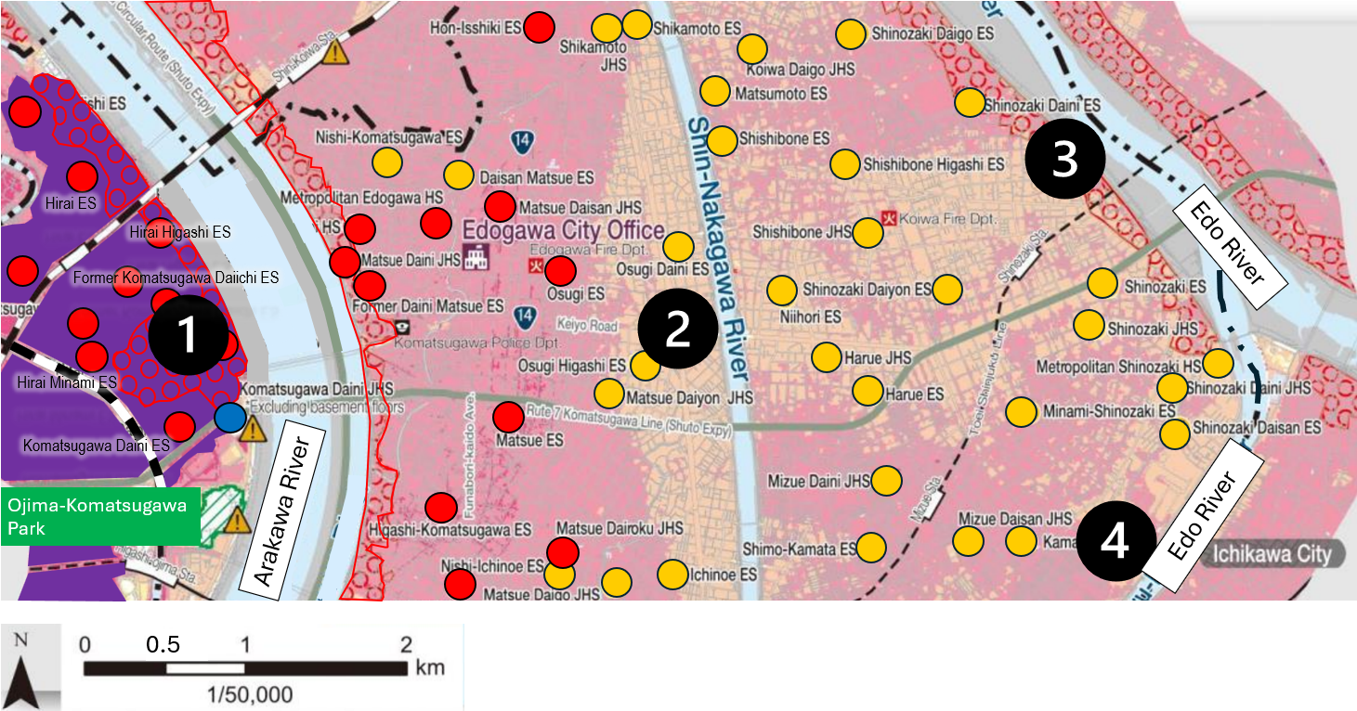

Legend:
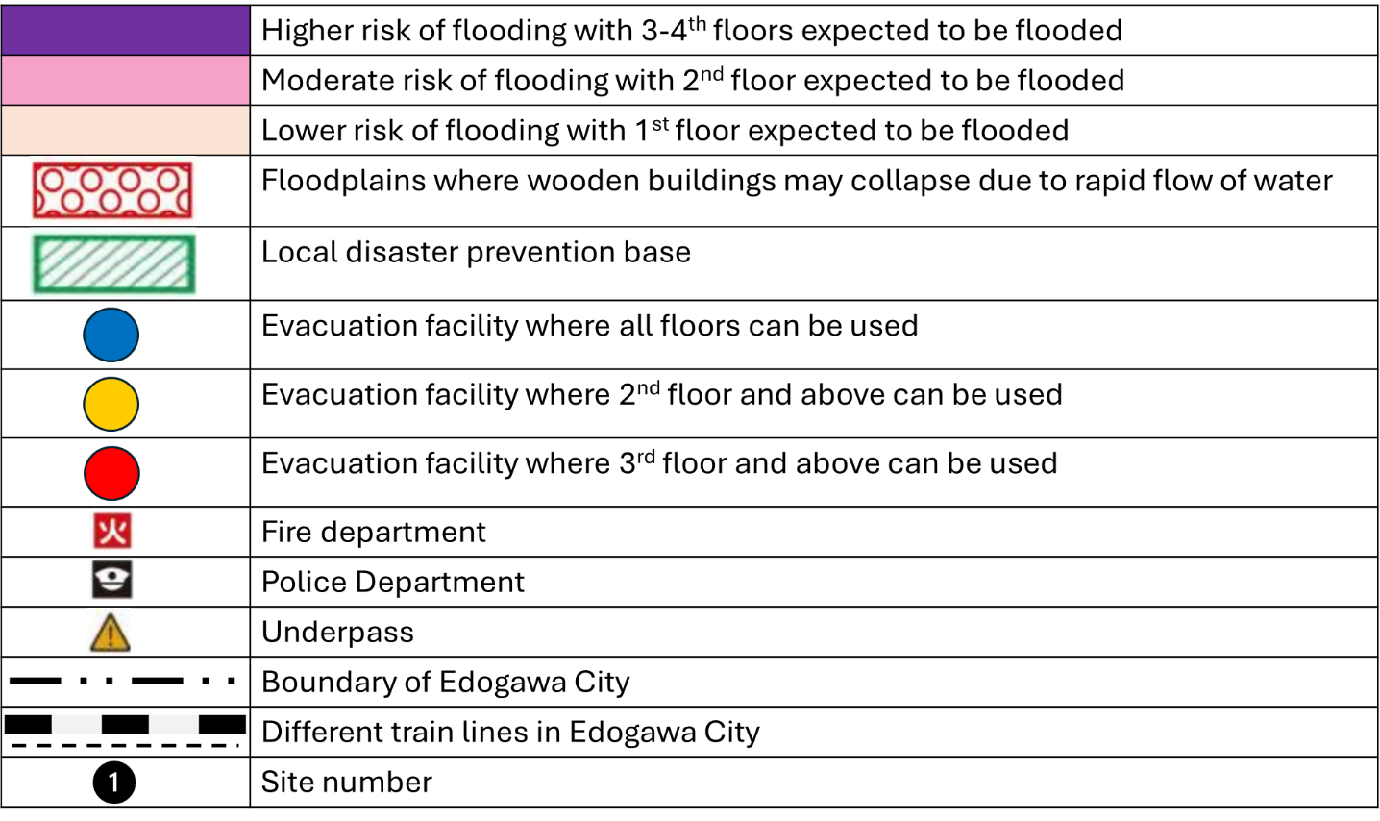

Resource 2 for Question 1

A ground view of one of the sites

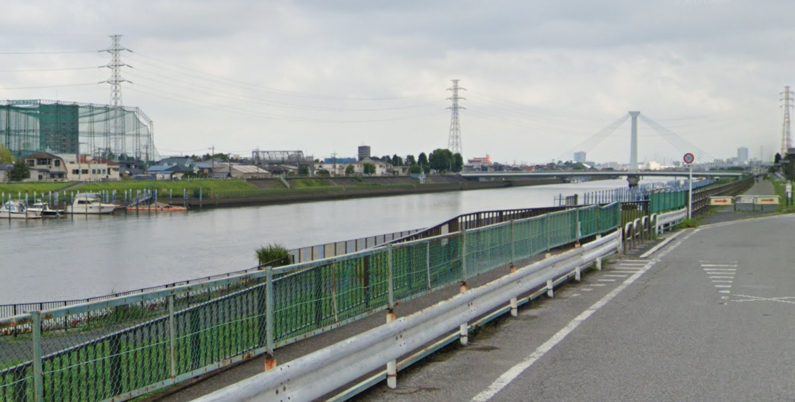

Note: All rivers are closely monitored by the city government. Permits are needed for any fishing or water activities.

Resource 3 for Question 1

River measurements of the four sites based on online sources

 | Velocity (m/s) | Width (m) | Average depth (m)
Site 1 | 0.25 | 650 | 12
Site 2 | 0.07 | 150 | 15
Site 3 | 0.1 | 250 | 11
Site 4 | 0.2 | 150 | 11

Resource 4 for Question 1

Questionnaire survey

Hi, we are students from a junior college in Singapore. As part of our school project, we are investigating into the flood risk of Edogawa City. We would appreciate if you could take some time to fill in the survey.

1. How long have you stayed, lived, or worked here?

≥30 years
15-30 years
6-14 years
≤ 5 years

2. How would you rate the flood risk in Edogawa City?

High
Medium
Low

3. How often does this area flood?

At least once in 10 years
At least once in 5 years
At least once a year
Never seen a flood here before

4. Do you feel vulnerable to floods? Please provide a short reason to your choice.

Yes because _____________________________________________________________
No because _____________________________________________________________

5. What is the most effective flood mitigation strategy that has been rolled out in Edogawa City?

Flood proofing of homes
Building of artificial levees
Floodplain zoning
Community preparedness through SMS alerts
Others: _______________________________

6. To what extent do you think that the flood management strategies have lowered the flood risk in Edogawa City?
____________________________________________________________________________

____________________________________________________________________________

____________________________________________________________________________

Thank you!

Resource 5 for Question 1

Tabulated results of Question 3 from the questionnaire survey

Results for Question 3 “How often does this area flood?”

 | At least once in 10 years | At least once in 5 years | At least once a year | Never seen a flood here before
Site 1 | 3 | 2 | 20 | 0
Site 2 | 10 | 4 | 3 | 8
Site 3 | 7 | 7 | 7 | 4
Site 4 | 0 | 6 | 19 | 0

Resource 6 for Question 2
Map of cities ranked by the City Liveability Index in 2024

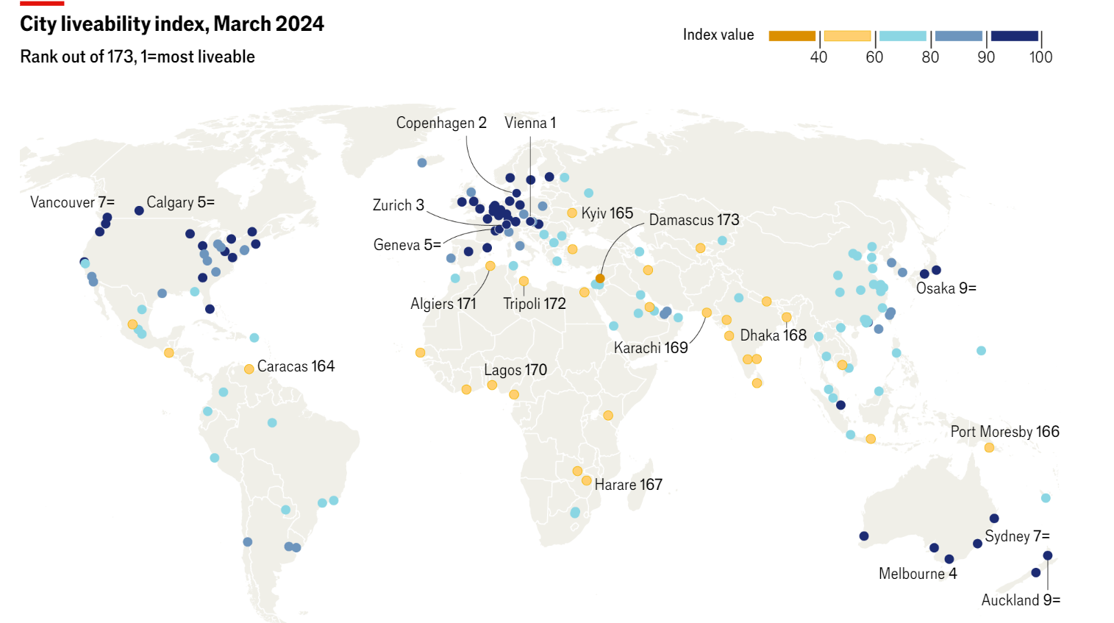

Resource 7 for Question 2

Location of green spaces and metro stations in Vienna, Austria

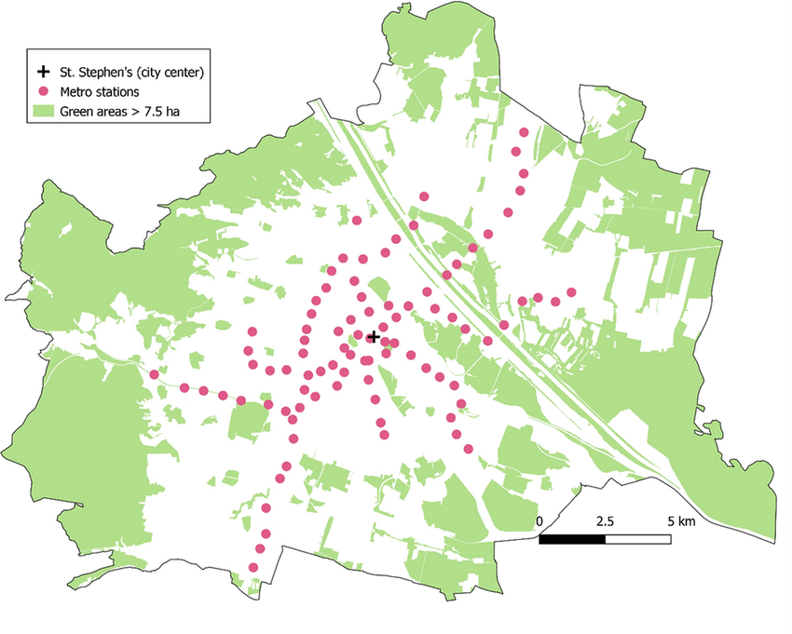

Resource 8 for Question 2

Adapted article excerpt on climate protection areas in Vienna, Austria

Vienna is taking a historic step towards a crisis-proof and renewable energy future. The phase-out of fossil fuel gas supply for buildings has begun. In June 2020, the first three climate protection areas were enacted in Vienna. In these areas, new buildings can only be built with a climate-friendly energy supply system. These buildings should be connected to the district heating system where at least 80% of the energy is renewable or from highly efficient power plants. Alternatively, they can rely on decentralized energy supply systems based on renewable energy sources (heat pumps, biomass heating systems, solar energy), provided air quality requirements are met. By autumn 2020, climate protection areas will be in force for 8 (of the 23) districts of Vienna. The rest will follow in 2021.

Resource 9 for Question 2

Inclusive urban design in Vienna, Austria

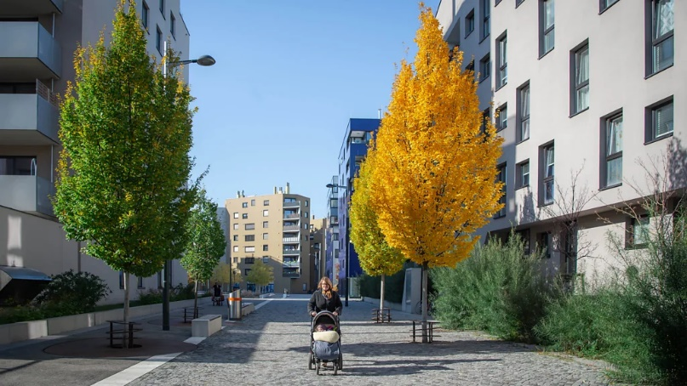

Wide pavements to accommodate strollers

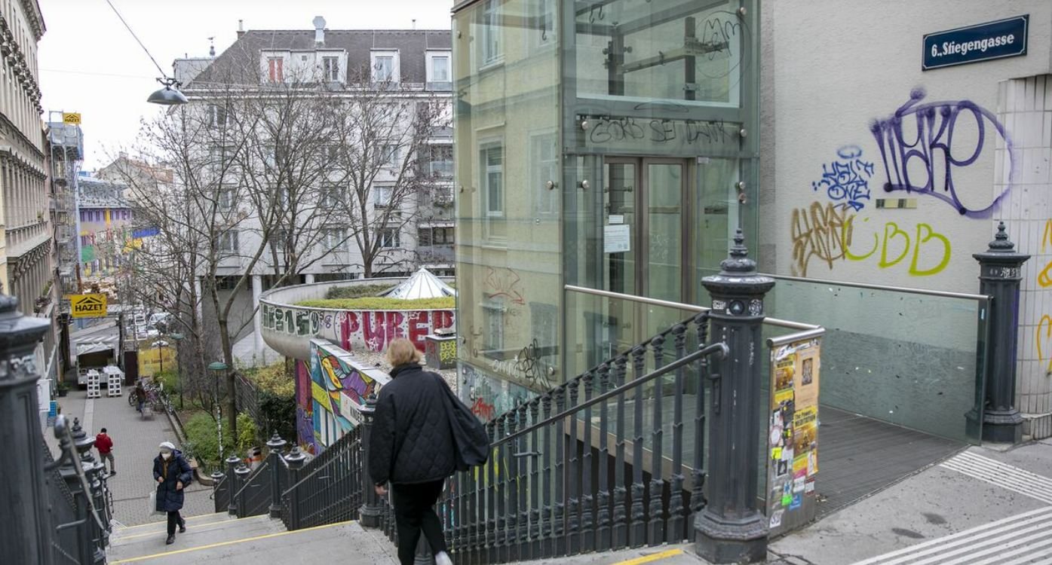

Installation of lift next to staircase

Sources

Resource 1 | https://www.city.edogawa.tokyo.jp/documents/519/sassien.pdf
Resource 2 | Google Maps
Resource 6 | https://www.economist.com/graphic-detail/2024/06/26/the-worlds-most-liveable-cities-in-2024
Resource 7 | Morawetz, U. & Klaiber, H. (2022). Does housing policy impact income sorting near urban amenities? Evidence from Vienna, Austria The Annals of Regional Science, 69.
Resource 8 | https://www.wien.gv.at/english/environment/energy/climate-protection-areas.html
Resource 9 | https://www.bbc.com/travel/article/20210524-how-vienna-built-a-gender-equal-city  https://www.meinbezirk.at/mariahilf/c-lokales/der-lift-faehrt-ab-februar-wieder_a5064751#gallery=default&pid=27953968

